

I like this logo because it’s clean and simple. I think I’m going to base the overall aesthetic on the simple cleanness of this logo.

The original smash bros series use a lot of different colours throughout their menus. It’s usually red which dominates since it’s used for the main, big buttons. I’m not following this style seeing as I dislike the use of too many colours in a website. It may work well in-game, but it would get way too messy and distracting if used in a bigger environment.

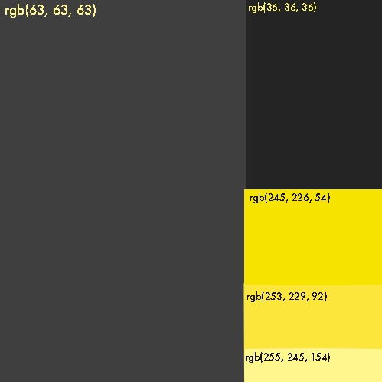The colour scheme I’ll be using is dark and focuses of yellow accent colours. I think red (the main colour used in the games) is too aggressive for a website, and yellow still evokes the emotion of “danger”: you challenging others to duel.